Professional Development Business Case  A short case to support your certification request — fill in the blanks and send to your manager. | 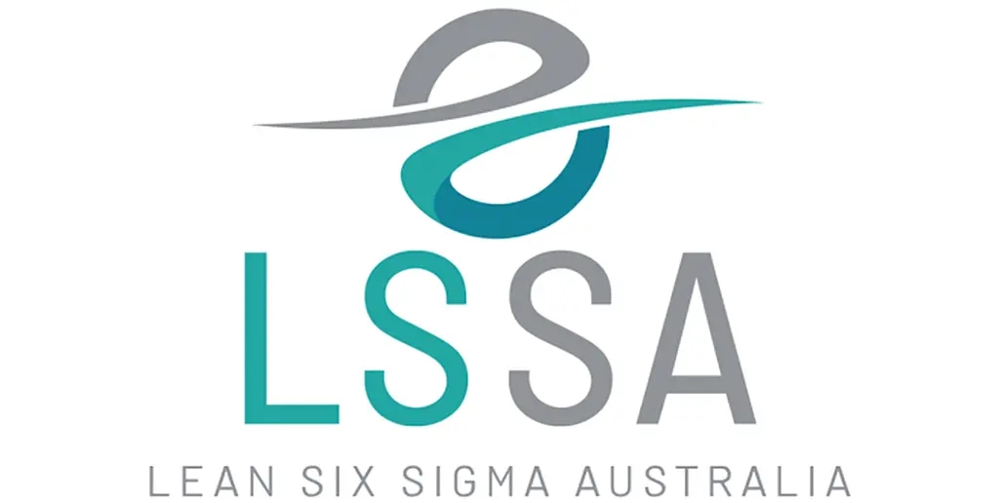

Requested by: |  | Date:
Course requested: |  | Cost:
Reference pricing: Yellow Belt $575 · Green Belt $1,495 · Black Belt $2,495 · bundles from $1,795 (see leansixsigmaaustralia.com.au for current pricing)

The problem this addresses
Describe the specific process, bottleneck, or recurring issue this training would help you fix — the more concrete, the stronger the case:
____________________________________________________________________________________________________
____________________________________________________________________________________________________
____________________________________________________________________________________________________

What this course delivers
- A structured, repeatable method (DMAIC — Define, Measure, Analyze, Improve, Control) for finding root causes and making fixes stick, not just guessing at a solution.
- A practical toolkit that applies directly to the problem above — the training is built around real workplace application, not theory alone.
- The ability to lead (Green/Black Belt) or meaningfully support (Yellow Belt) an improvement project immediately after certifying.

Why this is worth the investment
Most recurring process problems cost the business more each year — in rework, delay, or lost output — than the price of this course, once the true time and people cost is added up. A single improvement project applying these skills typically recovers the training cost many times over.
Estimated annual cost of the problem above (if known): __________________________________________________
Not sure yet? See the free diagnostic note below before estimating.

About the provider
Lean Six Sigma Australia (LSSA) has trained process improvement professionals since 2016, with a 90% course completion rate and personalised trainer support, trusted across the Asia-Pacific region. Training is fully online and self-paced, so it fits around existing workload rather than requiring time away from the business.

A free next step, for the business
Separately — and at no cost — LSSA also offers a free diagnostic (Online Business Improvement Solutions) that quantifies what a specific process problem is actually costing the business, reviewed personally by an LSSA expert before it's sent back. It's a low-risk way to put a real number behind the problem described above, whether or not this course goes ahead. Details: leansixsigmaaustralia.com.au/business-improvement-solutions/

Approved by: | Date: | Signature:

